
NAME: _________________________

____ / 50
Task 3 Landforms and Landscapes:
Geomorphic Hazards(Year 8)
Research Assessment- Due Week 2 Term 2

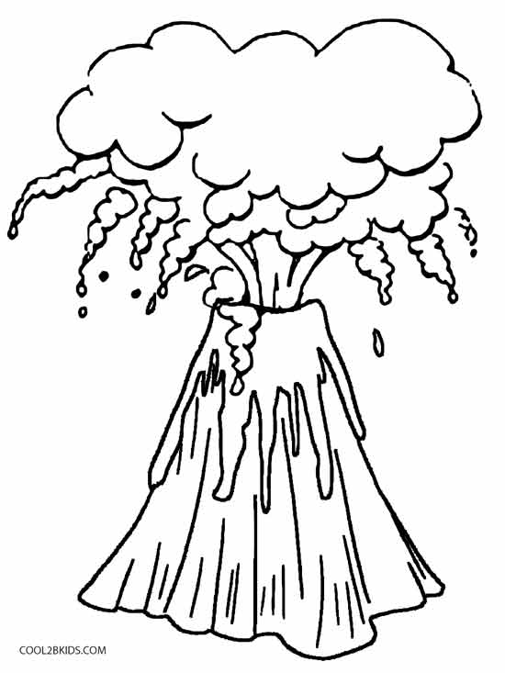
Geomorphic hazards result from the movement of tectonic plates. These are some examples of geomorphic hazard: volcanoes, earthquakes and tsunamis

Your Task:
To create a presentation to explain ONE geomorphic hazard of your choice. You also need to include the following information:
- Where they are found and why.
- How they occur.
- How often they occur.
- The dangers they pose/damage caused.
- How people can recover from them.
- How people can prepare for them.
- Any positive impacts/ results (for example minerals from volcanoes)

Your Assignment can be presented in one of the following formats:
- PowerPoint
- Report
- Poster
- 3D Model and Report (model must be labelled)
Focus Questions:

What is a geomorphic hazard?
What is your geomorphic hazard?
How and why do they happen?
Where do they occur? (Map/diagram)
Why do people live in areas where they occur?

How often do they occur?
What dangers can they pose?
What benefits can they provide?
How do people recover from them?
How can people be prepared for them? (Warning systems, evacuations)

You must submit (tick once you have completed):
- Brainstorm
- KWL Chart - topic
- Note taking sheets
- Final assignment presentation (PowerPoint, Poster or 3D model)
- Bibliography (Reference sheet)
- PMI chart - topic
- PMI chart - task
- Self-evaluation paragraph

It is important to READ the marking rubric and ensure you have completed and submitted what is required.
Marking Rubric –Geomorphic Hazards Task
Volcano Task | 1 | 2 | 3 | 4 | 5 | 6 | 7 | 8 | 9 | 10
Brainstorm
- Shows evidence of brainstorming the topic and what is required in the assignment.
KWL Chart
- At least 3 relevant points per column
Notes
- Students demonstrate clear evidence of note-taking and recording notes in key word form, notes are relevant to the assignment

PMI chart - topic
- At least 3 relevant points per column
- Student demonstrates evidence of reflection on the topic

PMI chart - task
- At least 3 relevant points per column
- Student demonstrates evidence of reflection on the task
Assignment Presentation
- Presentation is logical, addresses the assignment brief, follows one of the formats, is clear and information is both written and visual.
Bibliography
- A variety of sources are used (at least one book and one website)
- References are in the correct format
- All work is referenced (including images)
Self-evaluation
- Student provides observations of what they did well, what they did not do so well and at least one thing they could do to improve in the future.
Teacher’s comments:

50

